線上在學證明申請說明
Guidelines for online application for certificate of enrollment
因應資訊安全考量，本系統限制於校園網路內使用，於校外使用者請依說明使用 VPN 登入。
Due to information security, the Grading System is limited to access via the NYCU network domain only. For off-campus users to access these resources outside campus, please use the SSL VPN service provided by ITSC.
VPN 使用說明 About SSL-VPN Services
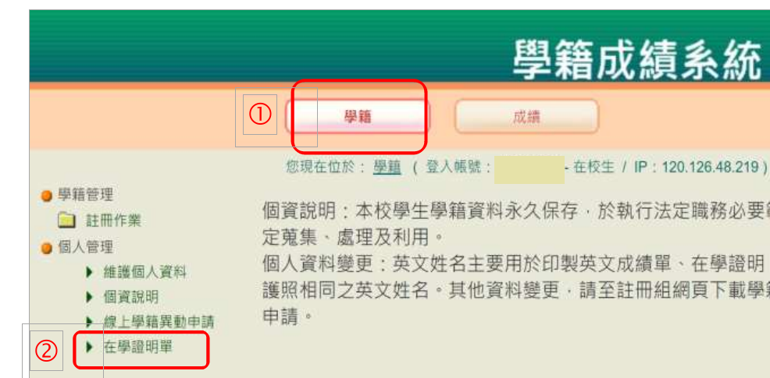
請完成學雜費繳交三~五工作日後再至系統下載。
Please complete the tuition fees payment first, and then you can enter the system to download the certificate of enrollment after３to５working days.
請依下方路徑說明進入學籍文件管理系統。
Please use the following path to access the Grading System.
路徑：國立陽明交通大學單一入口網／校務系統連結／陽明交通大學／學籍成績管理系統Access Path：Portal of NYCU／System Links／NYCU Campus／Grading System
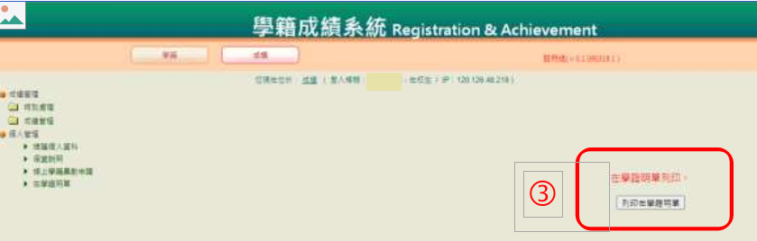
列印在學證明單

